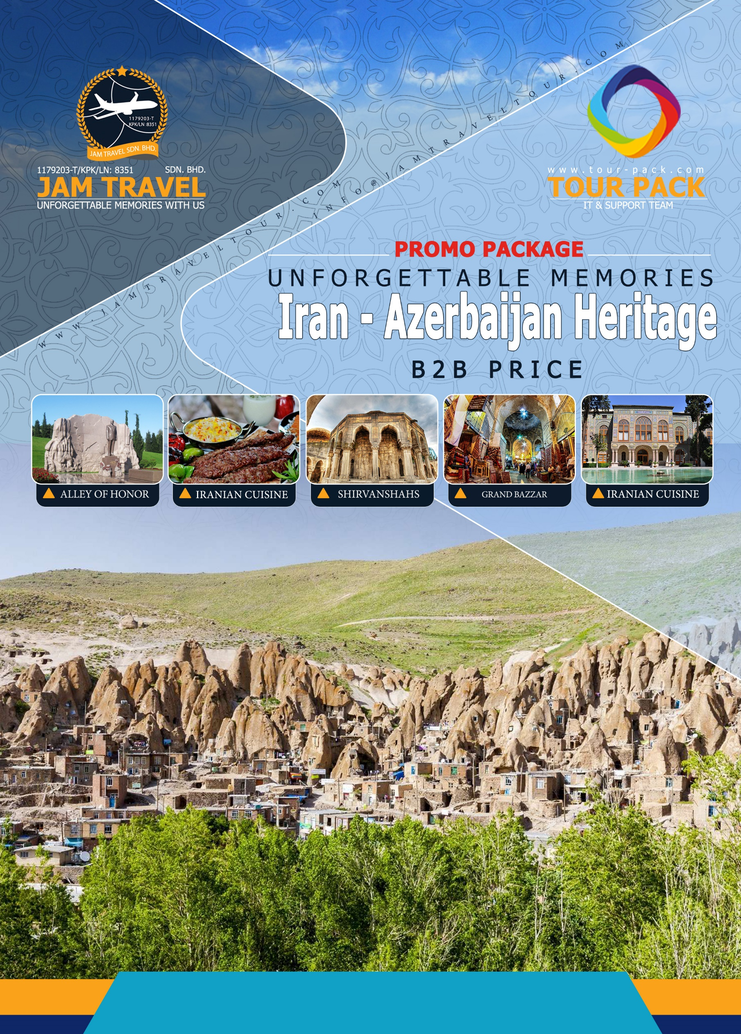

**Iran**-**Azerbaijan** Heritage

**9Days & 6nights**

Cities: Tehran (1N), Bandar Anzali (1N), Baku (2N), Tabriz (1N), Zanjan (1N)

**Mahan Air Airline, Arrival at Tehran Airport**

* **W5082 (International)**

**Kuala lumpur / Tehran**

Departure: 23:30 / Arrival: 03:30(+1)

* **W5083 (International)**

**Tehran / Kuala lumpur**

Departure: 21:55 / Arrival: 10:20(+1)

**Day 1: Tehran**

Meet and greet at the IKA airport with our professional tour guide then, transfer to the Hotel for brief refreshing then start the first day tour:

* **Azadi tower**: Formerly known as the shahyad Tower and is one of the landmarks of Tehran. It is about 148 ft. tall and is completely clad in cut marble
* **Golestan palace**: the glories and excesses of the Qajar rulers are played out across this complex of grand buildings decorated with beautifully painted tiles and set around an elegant garden that's worth visiting in its own right, and of world heritage status, UNESCO.
* **Grand Bazaar:** The maze of bustling alleys and the bazaris (shopkeepers) that fill them make this a fascinating, if somewhat daunting, place to explore. Despite being known as the Grand Bazaar, most of the architecture is less than 200 years old and pedestrian, although there are some gems to be found.
* **Carpet museum:** Carpet-weaving is undoubtedly one of the most distinguished manifestations of Iranian culture and art, dating back to the Bronze Age, but as the materials used in carpets including wool and cotton, decay into dust during the course of time, archaeologists couldn't make any special discovery during the archaeological excavations.
* **Nature Bridge**: The Tabi'at Bridge or Nature Bridge, is the largest pedestrian overpass built in Tehran, Iran. The 270-metre bridge connects two public parks—Taleghani Park and Abo-Atash Park—by spanning Modarres Expressway, one of the main highways in northern Tehran.

**O/N Tehran**

|  |  |  |  |
| --- | --- | --- | --- |
|  |  | |  |
| **Azadi Tower** | **Golestan Palace** | | **Grand Bazaar** |
|  | |  | |
| **Carpet museum** | | **Nature Bridge** | |

**Day 2: Tehran-Anzali [4 h 52min (364 km)]**

Drive to Anzali, on the way visiting:

* **Museum of Rural Heritage:** The GUILAN Rural Heritage Museum as an open-air museum which is devoted to the rural and ancestral life, is the first one in Iran and remains so far, the unique museum of this type in Iran and beyond in the Middle-East and the Central Asia. This Museum was designed to preserve and revive the material and spiritual heritage of GUILAN, a coastal region of the Caspian Sea in the North-West of Iran.
* **Anzali Lagoon:** Anzali Lagoon with an area of about 20 thousand hectares in the north of Iran is located in Gilan Province. Anzali Lagoon is one of the most interesting and greatest natural habitats of fauna in Iran and annually welcomes many birds that enter Iran from the neighboring countries. It is not comparable to any other lagoons in Iran due to its geographical position and in terms of its high humidity and water.

**O/N Anzali**

|  |  |
| --- | --- |
|  |  |
| **Anzali Lagoon** | **Museum of Rural Heritage** |

**Day 3: Anzali - Baku** **[6 h 5 min (432km)]**

Early Morning, after breakfastDrive to Baku, and will arrive in the Evening.

* **Nizami & Torgovaya Street:** It is a large pedestrian and shopping street in downtown [Baku](https://en.wikipedia.org/wiki/Baku), [Azerbaijan](https://en.wikipedia.org/wiki/Azerbaijan), named after classical poet [Nizami Ganjavi](https://en.wikipedia.org/wiki/Nizami_Ganjavi" \o "Nizami Ganjavi). The street's history could be traced back to Baku's town-planning project of 1864. The street runs through the city's downtown from west to east. The traffic-free segment, which begins at the [Fountains Square](https://en.wikipedia.org/wiki/Fountains_Square,_Baku) and ends at the [Rashid Behbudov Street](https://en.wikipedia.org/wiki/Rashid_Behbudov_Street), is commonly known as **Torgovaya** ("the merchant street" in Russian).

**O/N Bakou**

|  |  |
| --- | --- |
| Image result for Nizami & Torgovaya Street | Related image |
| **Nizami & Torgovaya Street** | **Old City** |
| Image result for Palace of Shirvanshahs | Image result for Baku Maiden Tower |
| **Palace of Shirvanshahs** | **Maiden Tower** |
| Image result for Boku Alley of Honor | Image result for Boku Upland Park |
| **Alley of Honor** | **Upland Park** |

**Day 4: Baku**

A full Day sightseeing starts with Old City

* **Old City:** or **Inner City** ([Azerbaijani](https://en.wikipedia.org/wiki/Azerbaijani_language): *İçərişəhər*) is the historical core of [Baku](https://en.wikipedia.org/wiki/Baku), the capital of [Azerbaijan](https://en.wikipedia.org/wiki/Azerbaijan). The Old City is the most ancient part of Baku, which is surrounded by walls were well protected. In 2007, the Old City had a population of about 3000 people.
* **Palace of Shirvanshahs:** The Palace of the Shirvanshahs ([Azerbaijani](https://en.wikipedia.org/wiki/Azerbaijani_language): *Şirvanşahlar Sarayı*) is a 15th-century palace built by the [Shirvanshahs](https://en.wikipedia.org/wiki/Shirvanshah" \o "Shirvanshah) and described by UNESCO as "one of the pearls of Azerbaijan's architecture". It is located in the Inner City of [Baku](https://en.wikipedia.org/wiki/Baku). In the past, the palace was surrounded by a wall with towers and, thus, served as the inner stronghold of the Baku fortress.
* **Maiden Tower:** ([Azerbaijani](https://en.wikipedia.org/wiki/Azerbaijani_language): *Qız qalası*) is a 12th-century monument in the [Old City](https://en.wikipedia.org/wiki/Old_City_(Baku)), [Baku](https://en.wikipedia.org/wiki/Baku), [Azerbaijan](https://en.wikipedia.org/wiki/Azerbaijan). Along with the [Shirvanshahs' Palace](https://en.wikipedia.org/wiki/Palace_of_the_Shirvanshahs" \o "Palace of the Shirvanshahs), dated to the 15th century, it forms a group of historic monuments listed in 2001 under the [UNESCO World Heritage List](https://en.wikipedia.org/wiki/UNESCO_World_Heritage_List) of Historical Monuments as cultural property, Category III. It is one of Azerbaijan's most distinctive national emblems, and is thus featured on [Azeri currency notes](https://en.wikipedia.org/wiki/Manat_(Azerbaijan)) and official letterheads.
* **Alley of Honor:** The **Alley of Honor** ([Azerbaijani](https://en.wikipedia.org/wiki/Azerbaijani_language): *Fəxri Xiyaban*, Honorary Alley) is a public [cemetery](https://en.wikipedia.org/wiki/Cemetery) and memorial in [Baku](https://en.wikipedia.org/wiki/Baku), [Azerbaijan](https://en.wikipedia.org/wiki/Azerbaijan). The Alley includes burials of famed [Azerbaijanis](https://en.wikipedia.org/wiki/Azerbaijanis) and Azerbaijan-affiliated [expatriates](https://en.wikipedia.org/wiki/Expatriate), including several [Presidents](https://en.wikipedia.org/wiki/President_of_Azerbaijan), scientists and artists. There are 242 burials in total.
* **Upland Park:** Baku's Upland Park is the highest point in the Azerbaijani capital, opening a panoramic view of the city and its bay. The city's residents and visitors often come here to see a bird's eye view of Baku, and just have a walk.

**O/N Baku**

**Day 5: Baku – Tabriz [7h 27min (535 km)]**

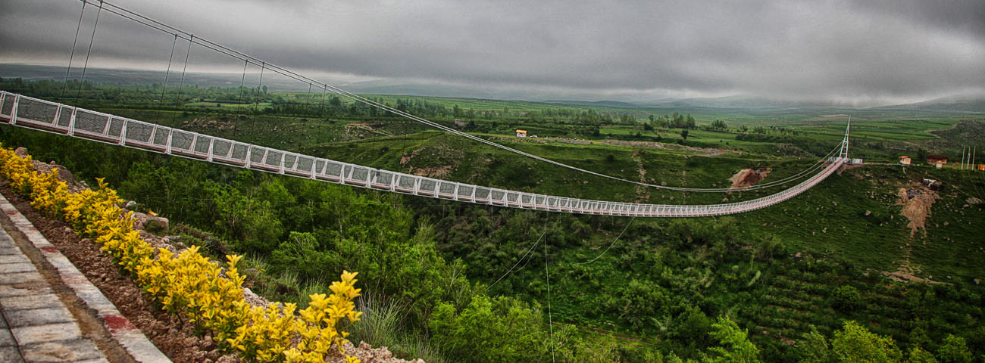

Early Morning, after breakfast Drive to Tabriz, on the way visiting.

* **Meshginshahr suspension bridge:** It is crosses the Khiav River, near [Meshginshahr](https://en.wikipedia.org/wiki/Meshginshahr" \o "Meshginshahr), [Ardabil Province](https://en.wikipedia.org/wiki/Ardabil_Province) in the [northwest](https://en.wikipedia.org/wiki/Azerbaijan_(Iran)) [Iran](https://en.wikipedia.org/wiki/Iran). It is the [Middle East](https://en.wikipedia.org/wiki/Middle_East)'s largest suspension bridge with a height of 80 meters (260 ft) and length of 365 meters (1,198 ft). The original bridge was built in 2015.

**O/N Tabriz**

**Day 6: Tabriz - Znjan [3h 30min (298 km)]**

After visiting attractions of Tabriz, and then you will Drive to Hamedan:

* **Blue Mosque:** is a famous historic mosque in Tabriz. The Blue mosque of Tabriz was built upon the order of Jahan Shah, the ruler of Kara Koyunlu.
* **Bazaar of Tabriz:** The Bazaar of Tabriz (also Romanized as Bāzār-e Tabriz) is a historical market situated in the city center of Tabriz, Iran. It is one of the oldest bazaars in the Middle East and the largest covered bazaar in the world. It is one of Iran's UNESCO World Heritage Sites**.** Inside the Tabriz bazaar, the mozaffarieh is one of the best places in Iran to buy a carpet.
* **El Goli:** It is also known as **Shah Gölü** ([Persian](https://en.wikipedia.org/wiki/Persian_language): شاه گلی‎, [Azerbaijani](https://en.wikipedia.org/wiki/Azerbaijani_language): *Şah Gölü*) is the name of a large historic park containing an artificial lake in south east of [Tabriz](https://en.wikipedia.org/wiki/Tabriz), [Iran](https://en.wikipedia.org/wiki/Iran). Shah Gulu's artificial lake is a rectangular lake surrounded by four sidewalks and a stripe of flowers in its four sides.

**O/N Zanjan**

|  |  |  |
| --- | --- | --- |
| Image result for blue mosque tabriz | Image result for Bazaar of Tabriz | Image result for El Goli Park |
| **Blue Mosque** | **Bazaar of Tabriz** | **El Goli Park** |

**Day 7: Zanjan – IKA [ 3 h 59 min (366 km)]**

The group will transfer early in the morning to IKA Airport to fly back home, on the way visiting:

* **ZANJAN ANTHROPOLOGICAL MUSEUM:** It is a traditional Qajar era laundry house and today it is Zanjan's Museum of Anthropology. This museum is located in the historical site of the beautiful edifice of the Rakhtshooy Khaneh in the renowned locality of Baba Jamal Charoqi of Zanjan. This is a remnant of the Qajar era and the museum displays fire exhibits related to the older times. Clothes or apparel that men and women wore, including handicrafts.
* **Dom of Soltaiyeh:** The central magnet of Soltaniyeh's several ruins is the Mausoleum of Il-khan Öljeitü also known as Muhammad Khodabandeh, traditionally known as the Dome of Soltaniyeh in Soltaniyeh city, Zanjan Province. The structure, erected from 1302 to 1312 AD, has the oldest double-shell dome in Iran.
* **Aminiha Hosseiniyeh:** It is a historic Hosseiniyeh in the Akhund (Molavi) neighborhood of Qazvin. Behind an unassuming brick wall is this well-preserved Qajar mansion built by a rich merchant in 1773. The courtyard garden is a pleasant place to linger after being dazzled by the mirrored, glittery interior, with its colored glass windows and vaulted basement.

|  |  |  |
| --- | --- | --- |
| Image result for ZANJAN ANTHROPOLOGICAL MUSEUM | Image result for â¢ Dome of Soltaniyeh | Image result for Aminiha Hosseiniyeh |
| **ZANJAN ANTHROPOLOGICAL MUSEUM** | **Bazaar of Tabriz** | **Aminiha Hosseiniyeh** |

**Mahan Air Airline, Departure from IKA Airport.**

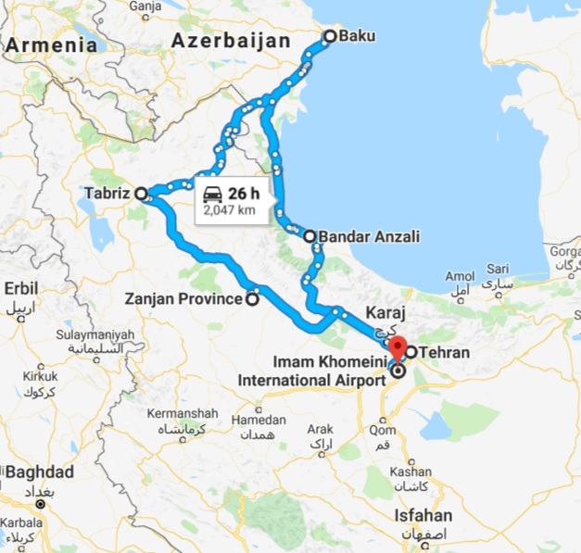

**Guide Map:**

* **Tehran**

*Tehran Province, Iran*

* **Bandar Anzali**

*Gilan Province, Iran*

* **Baku**

*Bakou Province, Azarbaijan Republic*

* **Tabriz**

*East Azerbaijan Province, Iran*

* **Zanjan**

*Zanjan Province, Iran*

* **Imam Khomeini International Airport**

*استان تهران Tehran Tehran-Qom، Road, Iran*

|  |  |  |
| --- | --- | --- |
| **ACCOMODATION** | | |
| **CITY** | **HOTELS** | **NIGHT** |
| **Tehran** | **Esteghlal West Tower 4* hotel** | **1** |
| **Anzali** | **Sefidkenar Hotel 4\*** | **1** |
| **Baku** | **Staybridge Suit or other 4* Hotel** | **2** |
| **Tabriz** | **Tabriz hotel 4\*** | **1** |
| **Zanjan** | **Bozorg Hotel 4\*** | **1** |

|  |  |
| --- | --- |
| **TOUR INCLUSIONS** | - International Flight (Mahan Air)  - All transfers  - All entrance fees  - English Tour guide throughout the tour  - Full Board Meal + Daily refreshment  - Travel Insurance  - Souvenir |
| **TOUR EXCLUSIONS** | - Any extra meals  - Any Extra Expenses  - All expenses from private nature such as  Phone/Fax/ Laundry/ Room Services  **- Tips 35 USD Per Passenger** |