BEST of IRAN
9Days 6Nights
Cities: Shiraz (2N), Isfahan (2N), Tehran (2N)

Mahan Air Airline, Arrival at Tehran Airport

- W5082 (International)
Kuala lumpur / Tehran
Departure: 23:30 / Arrival: 03:30(+1)
- W51089 (Domestic)
Tehran / Shiraz
Departure: 09:30 / Arrival: 10:50
- W5083 (International)
Tehran / Kuala lumpur
Departure: 21:55 / Arrival: 10:20(+1)

Day 1: KUALA LUMPUR / TEHRAN
Assemble 3 hours prior to departure at KLIA. Depart at 23:30 from Kuala Lumpur to Tehran.

Day 2: Tehran/Shiraz (Arrival – 1hr20min Flight)

Meet and greet at the IKA airport with our professional tour guide then, transfer to IBIS Hotel which is located next to IKA Airport, to pray and have breakfast then a pick-up transfer to Mehr Abad Airport for a domestic flight to Shiraz. After checking in Hotel then you can visit:
THR-SYZ by Domestic flight at 09:30 AM

- Shah e Cheragh Holy shrine: To Pray and Visit the shah cheragh complex (Shāh Chérāgh is a funerary monument and mosque in Shiraz, Iran, housing the tomb of the brothers Ahmad and Muhammad, sons of Mūsā al-Kādhimand brothers of ‘Alī ar-Ridhā.
- Tomb of Hafez: The Tomb of Hafez and its associated memorial hall, the Hāfezieh, are two memorial structures erected in the northern edge of Shiraz, Iran, in memory of the celebrated Persian poet Hafez.
O/N Shiraz

Shah e Cheragh Holy shrine | Tomb of Hafez
Day 3: Shiraz
Full day tour in Shiraz, visiting:
- Nasir almolk mosque: The Nasir al-Molk Mosque, also known as the Pink Mosque, is a traditional mosque in Shiraz, Iran
- Eram Garden: Eram Garden is a historic Persian garden in Shiraz, Iran. The garden, and the building within it, are located at the northern shore of the Khoshk River in the Fars province.
- Karim khan Citadel: The Karim Khan Castle is a citadel located in the downtown Shiraz, southern Iran. It was built as part of a complex during the Zand dynasty and is named after Karim Khan, and served as his living quarters. In shape it resembles a medieval fortress.
- Vakil Mosque: The Vakil Mosque is a mosque in Shiraz, southern Iran, situated to the west of the Vakil Bazaar next to its entrance. This mosque was built between 1751 and1773, during the Zand period; however, it was restored in the 19th century during the the Qajar period.
- Vakil Bazaar: Vakil Bazaar is the main bazaar of Shiraz, Iran, located in the historical enter of the city. It is thought that the market originally was established by the Buwayhids.
O/N Shiraz

Nasir Almolk mosque | Eram Garden | Karim khan Citadel
Vakil Mosque | Vakil Bazaar | Quran Gate

Day 4: Shiraz- Esfahan (6 h 15 min (496 km) / 2 stops at Persepolis & Pasargadae)
Drive to Isfahan, on the way visiting:
- Quran Gate: Qur'an Gate is a historic gate in the north of Shiraz, Iran. It is located at the north-eastern entrance of the city, on the way to Marvdasht and Isfahan, between Baba Kouhi and Chehel Maqam Mountains near Allah-O-Akbar Gorge.
- Persepolis: Persepolis was the ceremonial capital of the Achaemenes Empire. It is situated 60 km northeast of the city of Shiraz in Fars Province, Iran. The earliest remains of Persepolis date back to 515 BC. It exemplifies the Achaemenes style of architecture.
- Necropolis: A necropolis is a large, designed cemetery with elaborate tomb monuments. The name stems from the Ancient Greek νεκρόπολις Necropolis, literally meaning "city of the dead".
- Pasargadae: Pasargadae was the capital of the Achaemenes Empire under Cyrus the Great who had issued its construction; it was also the location of his tomb.

Arrive Esfahan, transfer to hotel and check in
- Sio se Pol Bridge: The Allah Verdi Khan Bridge, popularly known as Si-o-se-pol, is one of the eleven bridges in Isfahan, Iran.
O/N Isfahan

Persepolis | Necropolis
Pasargadae | Sio se Pol Bridge

Day 5: Isfahan
Full day tour of Isfahan, visiting:
- Chehel sotoun palace: Chehel Sotoun is a pavilion in the middle of a park at the far end of a long pool, in Isfahan, Iran, built by Shah Abbas II to be used for his entertainment and receptions
- Nagsh-e Jahan square: Naqsh-e Jahan Square, is a square situated at the centre of Isfahan city, Iran. Constructed between 1598 and 1629, it is now an important historical site, and one of UNESCO's World Heritage Sites. It is 160 metres wide by 560 metres long.
- Imam Mosque: The Shah Mosque, also known as Royal Mosque or Imam Mosque after Iranian revolution, is a mosque in Isfahan, Iran, standing in south side of Naghsh-e Jahan Square. Built during the Safavid Empire, ordered by Abbas I of Persia.
- Aali Qapoo Palace: Built at the very end of the 16th century as a residence for Shah Abbas I, this six-storey palace also served as a monumental gateway to the royal palaces that lay in the parklands beyond (Ali Qapu means ‘Gate of Ali’). Named after Abbas ’hero, the Imam Ali, it was built to make an impression, and at six storeys and 38m tall, with its impressive elevated terrace featuring 18 slender columns, it dominates one side of Naqsh-e Jahan (Imam) Sq.
- Sheikh Lotf Allah Mosque: Sheikh Lotfollah Mosque is one of the architectural masterpieces of Iranian architecture that was built during the Safavid Empire, standing on the eastern side of Naghsh-e Jahan Square, Esfahan, Iran.
- Bazaar: The Grand Bazaar is a historical market located in Isfahan, Iran, also known as "Qeysarriyeh Bazaar"
- Khajoo Bridge: Khaju Bridge is a bridge in the province of Isfahan, Iran, which has been described as the finest in the province. It was built by the Persian Safavid king, Shah Abbas II around 1650, on the foundations of an older bridge.
O/N Isfahan

Chehel sotoun palace | Nagsh-e Jahan square | Imam Mosque
Aali Qapoo Palace | Sheikh Lotf Allah Mosque | Khajoo Bridge

Day 6: Isfahan-Tehran (447 km / 2 stops at Kashan & Qom)
Drive to Tehran, through the way visiting:
- Abyaneh Village: Is one of the villages is one of the oldest in Iran, attracting numerous native and foreign tourists year-round, especially during traditional feasts and ceremonies.
- Fin’s garden: Fin Garden located in Kashan, Iran, is a historical Persian garden. It contains Kashan's Fin Bath, where Amir Kabir, the Qajarid chancellor, was murdered by an assassin sent by King Nasereddin Shah in 1852. Completed in 1590, the Fin Garden is the oldest extant garden in Iran.
- Hazrate Masoumeh Holy shrine: Fatima Masumeh was the sister of the eighth Imam Reza and the daughter of the seventh Imam Musa al-Kadhim (Tabari 60). In Shia Islam, women are often revered as saints if they are close relatives to one of the Twelver Imams. Fatima Masumeh is therefore honored as a saint, and her shrine in Qom is considered one of the most significant Shi'i shrines in Iran. Every year, thousands of Shi'i Muslims travel to Qom to honor Fatima Masumeh and ask her for blessings.

After visiting Qom, Group will drive toward Tehran, upon arrival tehran Transfer to hotel.
O/N Tehran

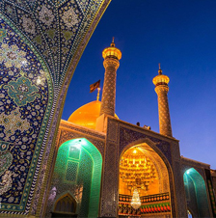 |  | 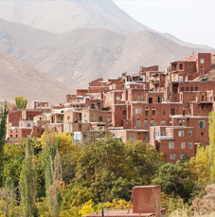
Masoumeh Holy shrine | Fin’s garden | Abyaneh Village

Day 7: Tehran
A full they sightseeing starts with Golestan Palace
  - Golestan palace: One of the oldest historic monuments in the city of Tehran, and of world heritage status, the Golestan Palace belongs to a group of royal buildings that were once enclosed within the mud-thatched walls of Tehran's arg ("citadel"). It consists of gardens, royal buildings, and collections of Iranian crafts and European presents from the 18th and 19th centuries.
  - Grand Bazaar: The maze of bustling alleys and the bazaris (shopkeepers) that fill themmake this a fascinating, if somewhat daunting, a place to explore. Despite being known asthe Grand Bazaar, most of the architecture is less than 200 years old and pedestrian, although there are some gems to be found.
  - Nature Bridge: (The Tabi'at Bridgeor Nature Bridge, is the largest pedestrian overpass built in Tehran, Iran. The 270-metre bridge connects two public parks—Taleghani Park and Abo-Atash Park—by spanning Modarres Expressway, one of the main highways in northern Tehran)
O/N Tehran

Golestan palace | Grand Bazaar
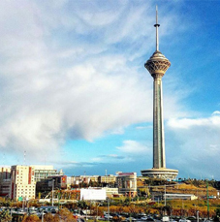
Milad Tower | Nature Bridge

Day 8: Tehran
A full day city tour of Tehran, transfer to Milad Tower:
- Milad tower: Milad Tower also known as the Tehran Tower is a multi-purpose tower in Tehran, Iran. It is the sixth-tallest tower and the 24th-tallest freestanding structure in the world. It is located between Qarb Town and the district of Gisha, standing at 435 meters from the base to the tip of the antenna. The head consists of a large pod with 12 floors, the roof of which is at 315 meters.
- Darband district: Darband formerly a village close to Tajrish, Shemiran, is a neighbourhood inside Tehran's metropolitan limits.[1] It is the beginning of a popular hiking trail into Mount Tochal, which towers over Tehran. A chairlift is also available for those not interested in hiking.
- Imamzadeh saleh: Imamzadeh Saleh is one of many imamzadeh mosques in Iran. The mosque is located at Tajrish Square in Tehran's northern Shemiran district. The mosque entombs the remains of Saleh, a son of the Twelver Shia Imam, Musa al-Kadhim, and is one of the most popular Shia shrines in northern Tehran.
In the evening after visiting Tajrish Bazaar and Emam Zade Saleh, the group will transfer to IKA Airport to fly back home.

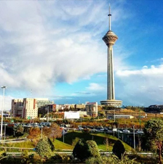
Milad Tower | Emamzade Saleh Mausoleum | Tajrish bazaar

Day 9: Kuala Lumpur (Arrival)
Landing at 10:20am in Kuala Lumpur International Airport. Home Sweet Home!

CITY |  | HOTELS 4* |  |  |  | NIGHT
Shiraz |  | Beyn Ol-Harameyn Hotel or similar |  |  |  | 2
Isfahan |  | Khajoo Hotel or similar |  |  |  | 2
Tehran |  | Persian PLaza Hotel or similar |  |  |  | 2
PAX | VEHICLE |  | DOUBLE PP |  | SINGLE PP |  | TRIPLE PP
1 - 2 | Sedan Car |  | RM 4,700 |  | RM 5,400 |  | RM 4,650
3 - 8 | Hyundai H350 |  | RM 4,400 |  | RM 5,100 |  | RM 4,350
9 - 14 | VIP Bus 25-Seater |  | RM 4,250 |  | RM 4,950 |  | RM 4,200
15 - 24 | VIP Bus 25-Seater |  | RM 4,000 |  | RM 4,700 |  | RM 3,950
25 - 30 | VIP Bus 31-Seater |  | RM 3,900 |  | RM 4,600 |  | RM 3,850
TOUR INCLUSIONS |  |  |  | TOUR EXCLUSIONS
- International & Domestic Flight  - Accommodations in 4-star Hotel with Breakfast  - All Transfers  - All Entrance Fees  - English Tour guide throughout the tour  - Full Board Meal  - Travel Insurance  - Daily Refreshment  - Free sim card with internet package for Tour Leader  - 1 FOC on Ground Tour for Tour Leader |  |  |  | - Any extra meals  - Any Extra Expenses  - All expenses from private nature such as  Phone/Fax/Laundry/Room Services  - Tips 35 USD by Passengers
CHILD DISCOUNT
- Age of 03-07 years old child sharing room with two adults (CHILD EXTRA BED) 25 % DISCOUNT
- Age of 03-07 years old child sharing room with two adults (CHILD NO BED) 40 % DISCOUNT
- Age of 03-07 years old child sharing room with one adult (CHILD TWIN) NO DISCOUNT
- Age of 00-02 years old child sharing room with two adults (INFANT) 100% DISCOUNT
- Age of 7 years and above no child discount is provided (ADULT)

ACCOMODATIONS:

Beyn Ol-Harameyn Hotel in Shiraz
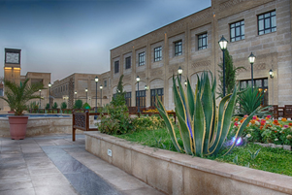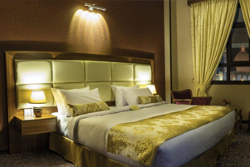
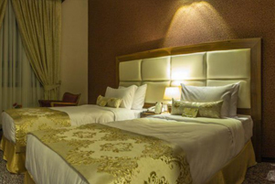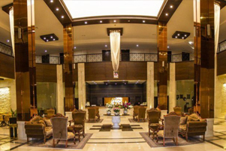

Khajoo Hotel in Isfahan:
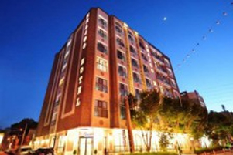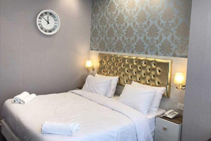
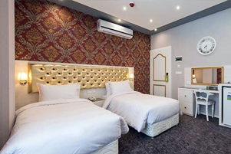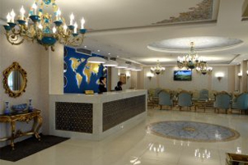

Parsian Kowsar Hotel in Tehran
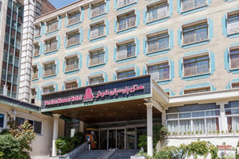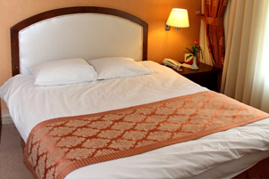
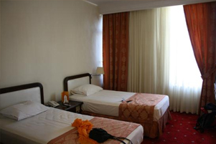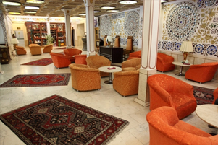

Transportation:
