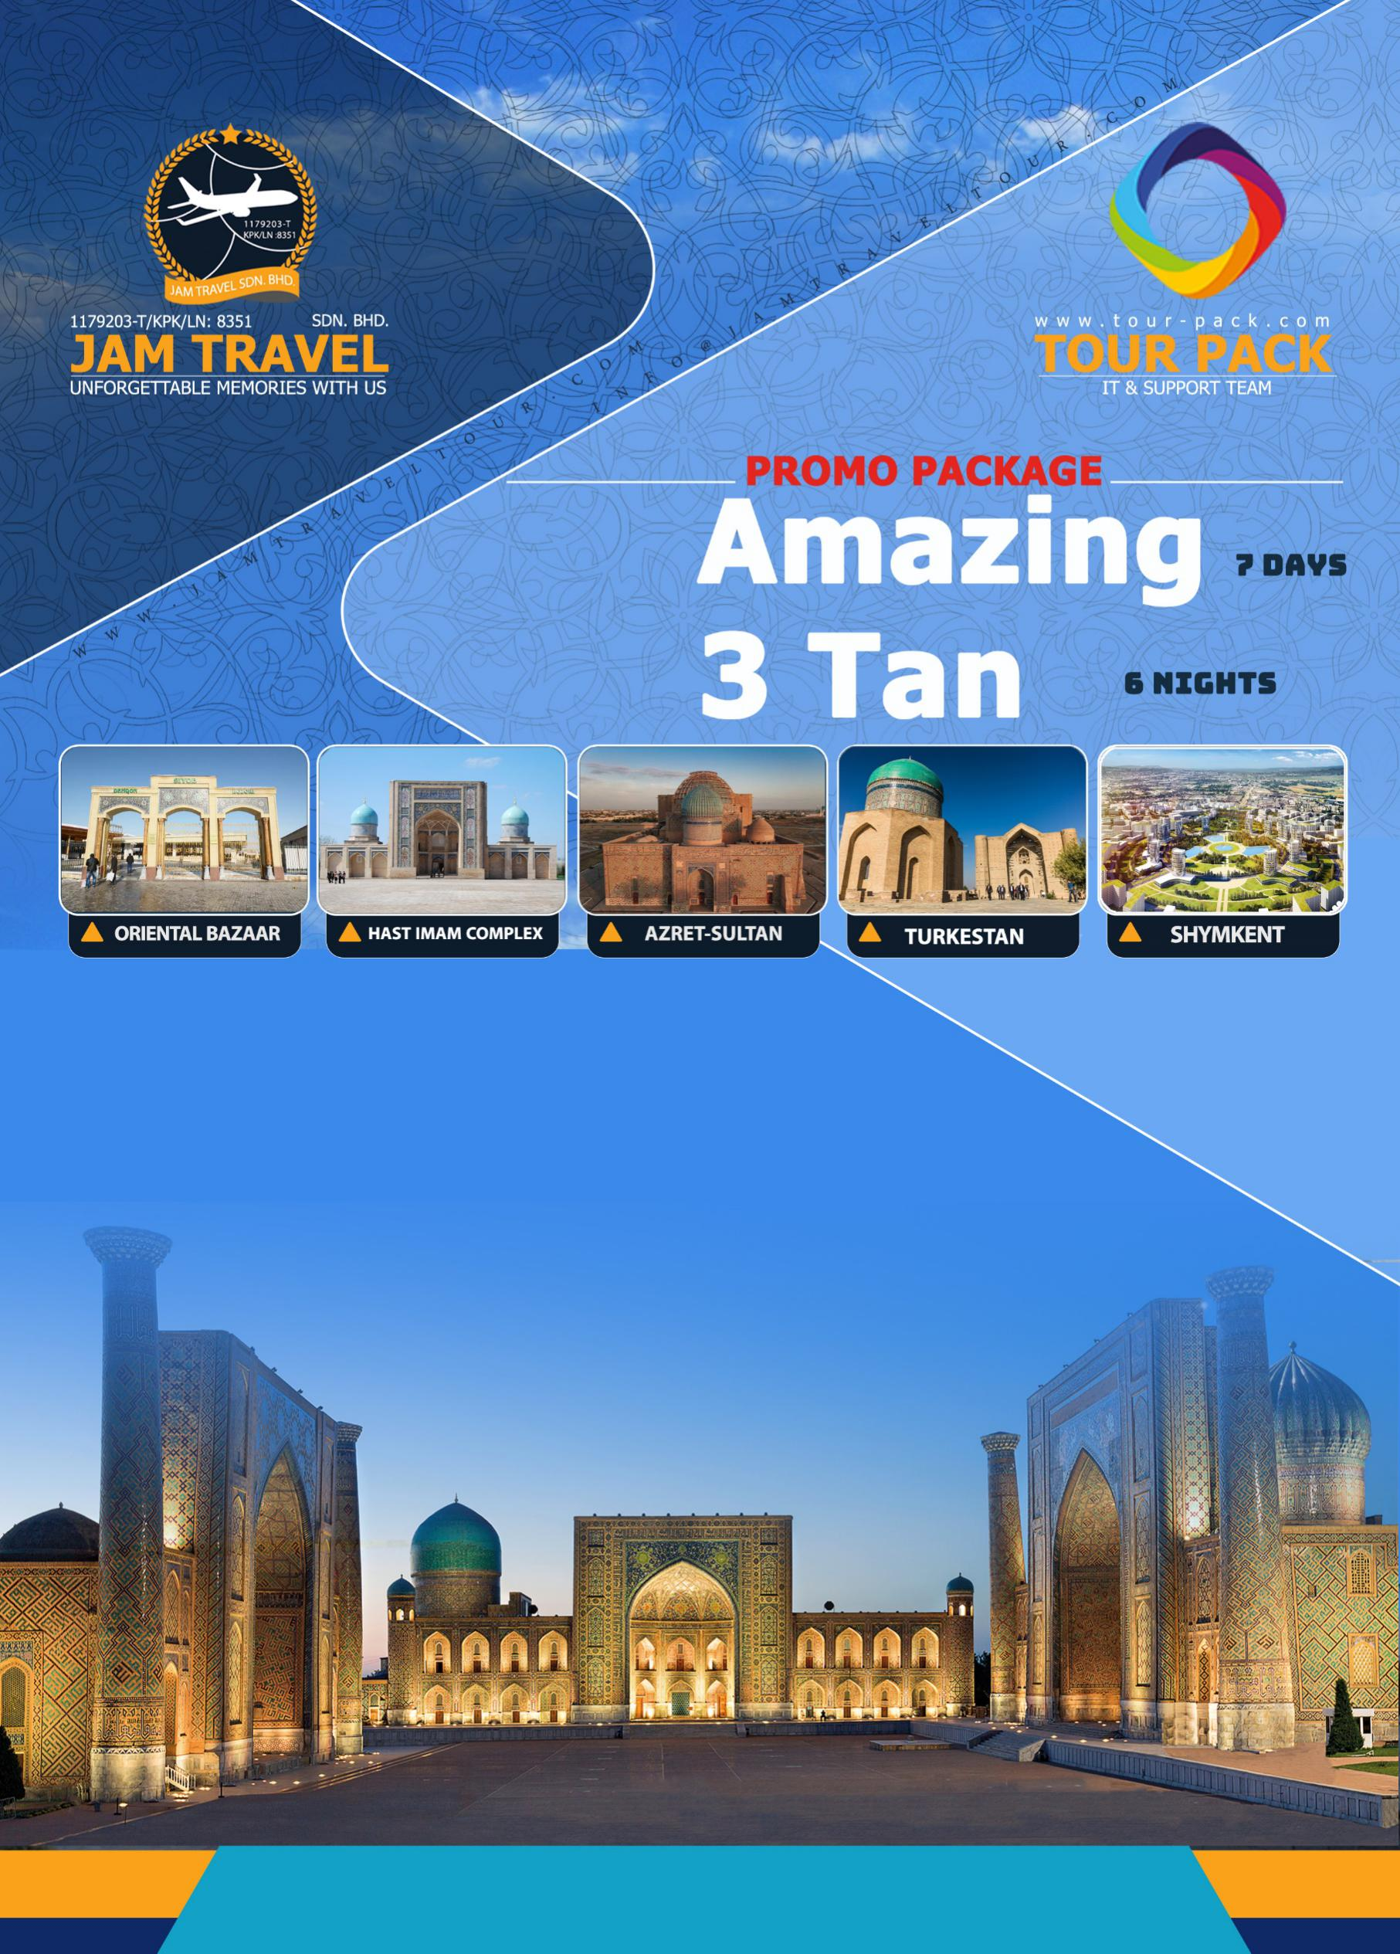
f

Amazing 3 Tan

8 Days 6 Nights

Cities: Shymkent (1N), Tashkent (3N), Samarkhand (1N), Bukhara (1N)

KC 936 | Kuala Lumpur - Almaty
10:10 Kuala Lumpur International Airport (KUL)
16:45 Almaty International (ALA)

KC 969 | Almaty - Shymkent
19:35 Almaty International (ALA)
21:05 Shymkent International (CIT)

KC 935 | Almaty - Kuala Lumpur
22:35 Almaty International (ALA)
08:45(+1) Kuala Lumpur International Airport (KUL)

Day 1: KLIA/ALMATY/SHYMKENT (Arrival – 1hr20min Flight)

Departure from KLIA to Almaty at10:10 by KC936. Khush Kelibsiz means Welcome!
At 16:45 arrival and transit to Shymkent at 19:35 by KC969. Arrival at 21:05 and meet with our guide and driver. Drive to the hotel for accommodation.

- Shymkent: Shymkent, is a city in the Republic of Kazakhstan; one of three cities which have the status equal to that of a region. It is the third most populous city in Kazakhstan behind Almaty and Nur-Sultan with an estimated population of 1,002,291 as of 1 June 2018.
O/N Shymkent

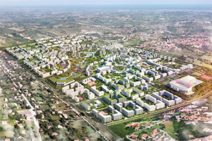
Shymkent
Day 2: SHYMKENT-TURKESTAN-TASHKENT

Our guide and driver will meet you at your hotel in Shymkent. Your unforgettable journey to history starts with a transfer to Turkestan city, one of the most ancient cities not only Kazakhstan but also in Central Asia.

- Turkestan: Turkestan was founded in 490 AD on the crossroad of trade routes from Samarkand, Bukhara and Khiva to the northern Kazakhstan. In the Middle Ages Turkestan was the administrative, political and religious centre of Central Asia. During 16th – 18th centuries it was the capital of Kazakh.

You will visit the "Azret-Sultan" historical and architectural complex, Khoja Ahmed Yasawi Mausoleum and Turkestan ancient settlement, where you will feel like you have been transferred back in time.

- Khoja Ahmed Yasawi Mausoleum: The Mausoleum of Khawaja Ahmed Yasawi is a mausoleum in the city of Turkestan, in southern Kazakhstan. The structure was commissioned in 1389 by Timur, who ruled the area as part of the expansive Timurid Empire, to replace a smaller 12th-century mausoleum of the famous Turkic poet and Sufi mystic, Khoja Ahmed Yasawi.
- Visit Turkestan ancient settlement and Azret-Sultan: The Karim Khan Castle is a citadel located in the downtown Shiraz, southern Iran. It was built as part of a complex during the Zand dynasty and is named after Karim Khan and served as his living quarters. In shape it resembles a medieval fortress.

Lunch at Restaurant. You will be driven back to the border of Gisht-Koprik between Uzbekistan and Kazakhstan. Go through border control. Then, Meeting with our driver and transfer to the hotel in Tashkent. Dinner at Restaurant.:
O/N Tashkent

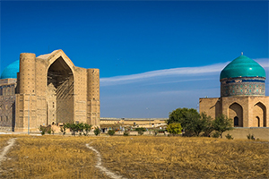 | 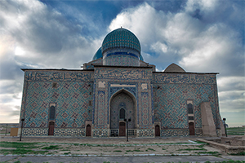 | 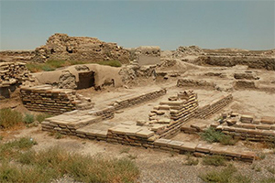
Turkestan | Khoja Ahmed Yasawi Mausoleum | Turkestan ancient settlement
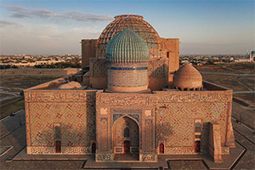
Azret-Sultan

Day 3: TASHKENT

Early breakfast and start Tashkent city tour with the old part of Tashkent, visiting Hast Imam complex, Chorsu bazaar and Kukeldash Madrassah:

- Kukeldash Madrassah: Kukeldash Madrasah is a medieval madrasa in Tashkent, located close to Chorsu Bazaar and Chorsu Metro station. It was built around 1570 by the Shaybanid Dynasty of rulers. The madrasah is built of yellow brick, and has a traditional square shape with a big portal and an inner yard.

Lunch at a local restaurant. After lunch continue the excursion program: visit the modern part of the city - Independence Square, Amir Temur Square, Museum of Timurids' history, Museum of Islam Karimov, Tashkent Metro.

- Amir Temur Square: Monumental square with fountains & esplanades around an equestrian statue of 1300s ruler Timur.
- Tashkent Metro: The Tashkent Metro is the rapid transit system serving the city of Tashkent, the capital of Uzbekistan. It is one of only two subway systems currently operating in Central Asia. It was the seventh metro to be built in the former USSR, opening in 1977. Its stations are among the most ornate in the world.
O/N Tashkent

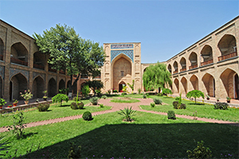 | 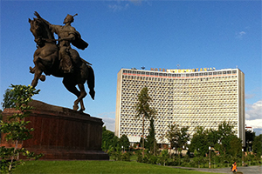 | 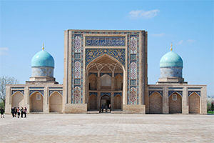
Kukeldash madrassah | Amir Temur Square | Tour of Hast Imam complex
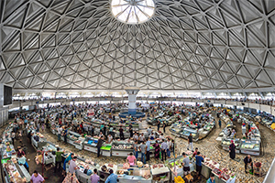 | 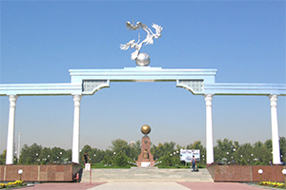 | 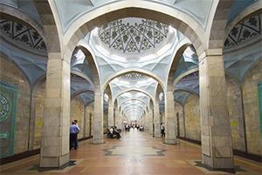
Chorsu bazaar | Independence Square | Tashkent Metro

Day 4: TASHKENT - SAMARKAND
Breakfast at the hotel. At 08:00 transfer to Samarkand by bullet train Afrosiyob. At 10:10 arrival and Full day excursion program in Samarkand.

- Gur-e-Amir: The Gūr-i Amīr or Guri Amir is a mausoleum of the Asian conqueror Timur in Samarkand, Uzbekistan. It occupies an important place in the history of Persian-Mongolian Architecture.
- Registan Square: The Registan was the heart of the ancient city of Samarkand of the Timurid dynasty, now in Uzbekistan. The name Rēgistan means "Sandy place" or "desert" in Persian.

Lunch at a local restaurant. Check-in the hotel. Visiting:

- Bibi-Khanum Mosque: The mosque Bibi-Khanym Mosque is one of the most important monuments of Samarkand. In the 15th century it was one of the largest and most magnificent mosques in the Islamic world. By the mid-20th century only a grandiose ruin of it still survived, but major parts of the mosque were restored during the Soviet period.
- Khazrati Khizr and oriental bazaar Siyab (At the request of the guests can visit “Meros” Paper Mill)
O/N Samarkand

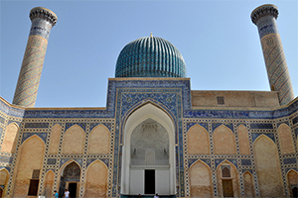 | 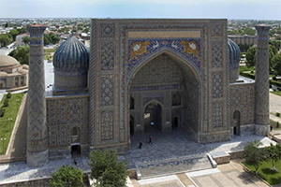
Gur-e-Amir | Registan Square
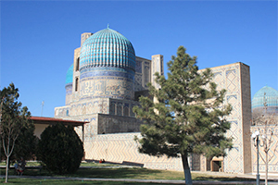 | 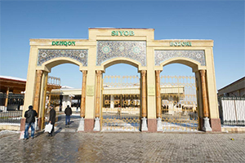
Bibi-Khanum Mosque | Oriental bazaar
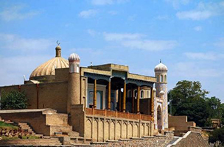 | 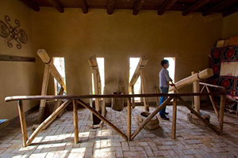
Khazrati Khizr | “Meros” Paper Mill

Day 5: SAMARKAND - BUKHARA
Breakfast at the hotel. Transfer to Bukhara at 09:50 by high speed train Afrosiyob. Arrival at 11:20 and start half day tour with a guided walking tour in the historic part of Bukhara listed by UNESCO as a World Heritage Site, visiting:

- Lyabi-Khauz Ensemble
- Poi-Kalyon complex: Po-i-Kalan or Poi Kalan, is an Islamic religious complex located around the Kalan minaret in Bukhara, Uzbekistan.
- Ulugbek and Abdulazizkhan Madrasahs
- Samanids' Mausoleum: The Samanid mausoleum is in a park just outside the historic urban centre of Bukhara.
- Chashma-Ayub Mausoleum: Chashma-Ayub Mausoleum is located near the Samani Mausoleum, in Bukhara, Uzbekistan. Its name means Job's well, due to the legend in which Job visited this place and made a well by striking the ground with his staff. The water of this well is still pure and is considered healing.
- Bolo Haouz Mosque: Bolo Haouz Mosque is a historical mosque in Bukhara, Uzbekistan. Built in 1712, on the opposite side of the citadel of Ark in Registan district, it is inscribed in the UNESCO World Heritage Site list along with the other parts of the historic city.
- Ark of Bukhara: The Ark of Bukhara is a massive fortress located in the city of Bukhara, Uzbekistan that was initially built and occupied around the 5th century AD. (At the request of the guests can dine with dance show program in Nadir Divan-Begi Madrassah)
O/N Bukhara

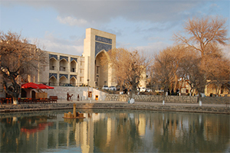 | 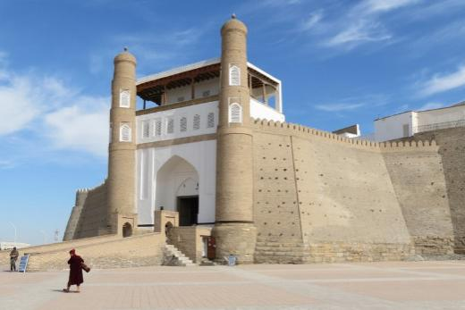 | 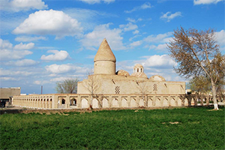
Lyabi-Khauz Ensemble | Ark Fortress | Chashma-Ayub Mausoleum
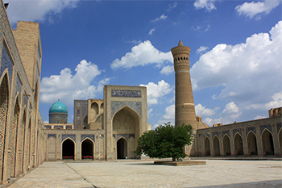 | 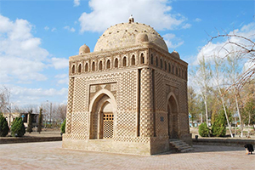 | 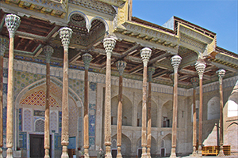
Po-i-Kalyan | Samanids' Mausoleum | Bolo Hauz Mosque

Day 6: BUKHARA - TASHKENT

After breakfast continue tour out of the city, visiting:

- Bahouddin Naqshband Mausoleum: The great theologian of the XIV century, founder of the Sufi Order "Naqshbandia" was buried 12 km from Bukhara in his native village of Kasri.
- Visit Sitorai Mokhi Khosa Palace: The former summer residence of Bukhara’s last emir. This is a unique site combining Oriental and Russian architecture.
Lunch at Restaurant. Free time to shopping. Then, drive to Railways Station. Take the fast-speed train departing to Tashkent at 15:50. Arrival at 19:40 and accommodation. (Massage services is available upon guest request). Dinner.
O/N Tashkent

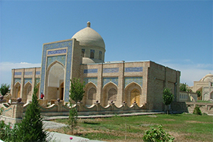 | 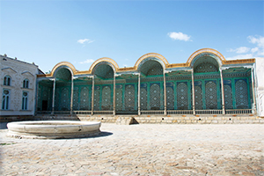
Bahouddin Naqshbandi Mausoleum | Sitorai Mokhi Khosa Palace

Day 7: TASHKENT - ALMATY - KLIA

Breakfast at the hotel. Half-day shopping in bazaar and Samarkand Darvoza Mall. Free and easy. Lunch at Restaurant. Drive to International Airport for the flight to Almaty at 14:20 by KC128. Upon arrival connecting flight to KLIA at 22:40. Khayir Sogh Buling – Uzbek traditional farewell and good wishes.

Day 8: Arrival to Kuala Lumpur

Landing at 8:45 in Kuala Lumpur International Airport. Home Sweet Home!

Map guide:

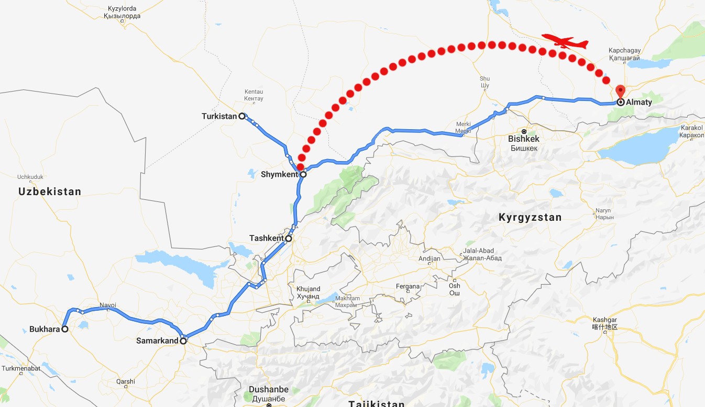

City | 4 Star Hotels |  | Nights
Shymkent | Shymkent Grand hotel |  | 1
Tashkent | Le Grande Plaza hotel |  | 3
Bukhara | Devon Begi hotel |  | 1
Samarkand | Zilol Baxt hotel |  | 1
TOUR INSCLUSIONS |  | TOUR EXCLUSIONS
- Accommodation in centrally located hotels (best available) with private facilities and daily breakfast  - All transfers and full transportation services  - Comprehensive sightseeing, visits to museums and attractions including entrance fees as per itinerary  - English speaking guide (Panduan berbahasa Melayu +155 USD p.p.)  - Train tickets  - Meals (6 Lunch and 6 Dinner) |  | - International & Domestic Flights  - 35 USD Per Pax  - Any services not included in the above itinerary

Shymkent Grand hotel:
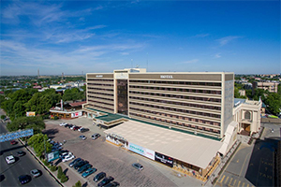 | 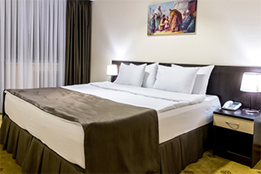
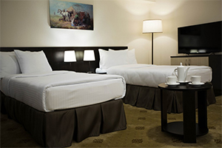 | 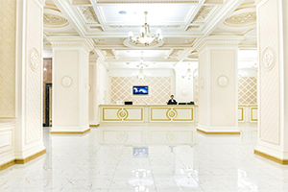

Le Grande Plaza hotel:
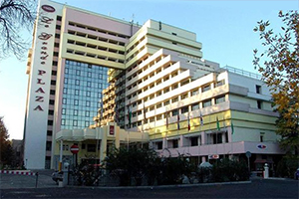 | 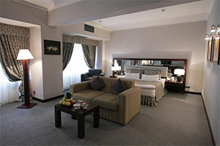
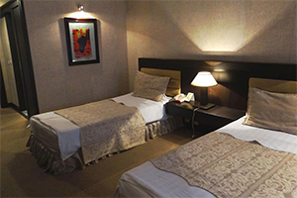 | 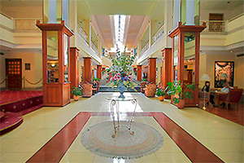

Devon Begi hotel:
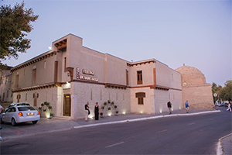 | 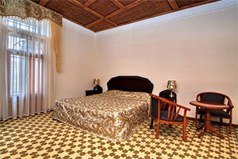
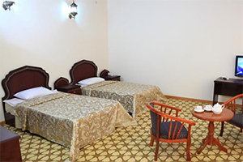 | 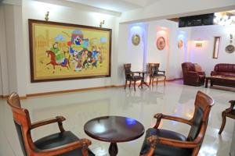

Zilol Baxt hotel:
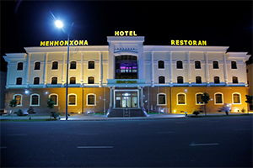 | 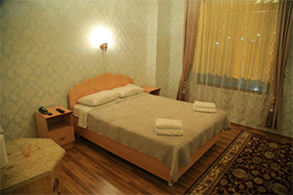
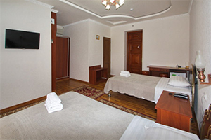 | 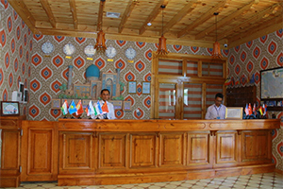

Afrosiyob Train:
