IRAN-DUBAI Combo Tour
8Days 5Nights

Cities: Tehran (2N), Isfahan (1N), Matinabad Eco Camp (1N), Dubai (1N)
Mahan Air Airline, Arrival at Tehran Airport

Kuala Lumpur-Dubai
KUL/IKA/DXB
W5082 | Departure: 23:15 | Arrival: 02:45(+1)
W5061 | Departure: 07:00 | Arrival: 09:30

Dubai-Tehran (Day 3)
DXB/IKA
W5064 | Departure: 21:00 | Arrival: 22:30

Tehran-Kuala Lumpur (Day 6)
IKA/KUL
W5083 | Departure: 21:30 | Arrival: 10:00(+1)

Day 1: Kuala Lumpur-Tehran/Dubai
Assemble at KLIA, 3 hours prior to flight for flight to Dubai (Transit Tehran)

Day 2: Dubai (Arrival)

Arrival in Dubai International airport. Meet and greet with our professional tour guide then, proceed on Dubai city tour including a visit to Gold Souk, Spice Souk, Dubai Museum, Abra ride and Photo stop at Jumeirah beach with the background of Burj Al Arab.
* Entrance fees for Dubai museum & Abra ride are included

- Gold Souk & Spice Souk: The souk is in Dubai's commercial business district in Deira, in the locality of Al Dhagaya. The souk consists of over 380 retailers, most of whom are jewellery traders. The major items of the mall include Gold, Platinum, Diamonds and sometimes also deals in silver. Stores in the Spice Souk sell a variety of fragrances and spices from frankincense and shisha to the many herbs used in Arabic and South Asian food.
- Dubai Museum: Dubai Museum is the main museum in Dubai, United Arab Emirates. It is in the Al Fahidi Fort, built in 1787 and is the oldest existing building in Dubai.
- Abra Ride: One of these must-do experiences is a trip on an abra ride across one of the Emirate's waterways. Traditionally made of wood, abra's are used to ferry people, whether as a taxi service, a trip for tourists or for businesses to move products and members of staff.
- Jumeirah Beach: The beach and its frontage feature large hotels, resorts, and housing developments, including the Burj Al Arab (Arab Tower) hotel, Wild Wadi Water Park, Jumeirah Beach Hotel, and the old-style Madinat Jumeirah, a hotel and shopping complex.
O/N Dubai

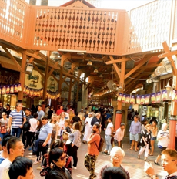 | 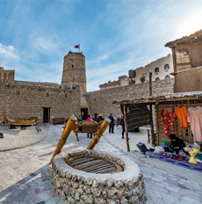
Gold Souk & Spice Souk | Dubai Museum
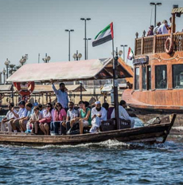 | 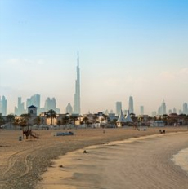
Abra Ride | Jumeirah Beach

Day 3: Dubai-Tehran (Departure)

Check-out after breakfast, proceed on Dubai city tour including a visit to Palm Jumeirah with One-way Monorail ride, Photo stop outside Atlantis The Palm Hotel and Miraj Islamic Centre (Compulsory visit).
* Entrance fees for One-way Monorail ride are included.

- Palm Jumeirah: The Palm Jumeirah is an artificial archipelago in the United Arab Emirates, created using land reclamation by Nakheel which extends into the Persian Gulf.
- Atlantis The Palm Hotel: Atlantis The Palm, Dubai is a luxury hotel resort located at the apex of the Palm Jumeirah in the United Arab Emirates. It was the first resort to be built on the island and is themed on the myth of Atlantis but includes distinct Arabian elements.
- Miraj Islamic Centre: Miraj Islamic Art Centre, a group dedicated to heritage, history and glory of Islam. The rare and pristine works of art on display at MIRAJ Islamic Art Centre are unique creations of this unique organization, held in high esteem in the art world.

Lunch at Mumtaz Mahal Arabian Courtyard (Buffet with water). Proceed on Dubai city tour including a visit to Leather shop (Compulsory visit), Photo stop at outside Ski Dubai and
Shopping at Mall of the Emirates. Transfer to Dubai International airport to departure to Tehran.
Arrival to Tehran at 10:30pm, Meet and greet at the IKA airport with our professional tour guide and transfer to hotel.
O/N Tehran

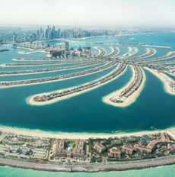 | 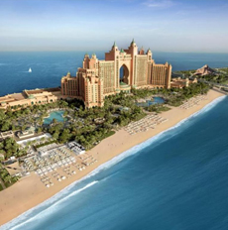 | 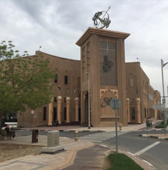
Palm Jumeirah | Atlantis The Palm Hotel | Miraj Islamic Centre

Day 4: Tehran

After breakfast a full day sightseeing starts with Golestan Palace:
  - Golestan Palace: One of the oldest historic monuments in the city of Tehran, and of world heritage status, the Golestan Palace belongs to a group of royal buildings that were once enclosed within the mud-thatched walls of Tehran's arg ("citadel"). It consists of gardens, royal buildings, and collections of Iranian crafts and European presents from the 18th and 19th centuries.
  - Grand Bazaar: The maze of bustling alleys and the bazaris (shopkeepers) that fill themmake this a fascinating, if somewhat daunting, a place to explore. Despite being known asthe Grand Bazaar, most of the architecture is less than 200 years old and pedestrian, although there are some gems to be found
  - National Museum: The National Museum of Iran is in Tehran. It is an institution formed of two complexes; the Museum of Ancient Iran and the Museum of the Islamic Era, which were opened in 1937 and 1972, respectively. The institution hosts historical monuments dating back through preserved ancient and medieval Iranian antiquities, including pottery vessels, metal objects, textile remains, and some rare books and coins.
  - Nature Bridge: The Tabi'at Bridgeor Nature Bridge, is the largest pedestrian overpass built in Tehran, Iran. The 270-metre bridge connects two public parks—Taleghani Park and Abo-Atash Park—by spanning Modarres Expressway, one of the main highways in northern Tehran
O/N Tehran
Golestan Palace | Grand Bazaar
National Museum | Nature Bridge

Day 5: Tehran - Isfahan [4 h 45 min (455 km)]
Today early morning after breakfast, we head toward Isfahan on the way visiting Abyaneh village one of the oldest villages in Iran. It is known to have existed 2,500 years ago.
- Abyaneh Village: The picturesque village is surrounded by mountains and guarded by three forts, that have been long abandoned. The Palahamoona Fort (Takht-e-Haman) is believed to have been built over 200 years ago and is situated in the south-west of Abyaneh, across the Barzrud River. If you know your way around, you will be able to walk towards this fort and see the spectacular panorama of the village with its beautiful mountain backdrop.
After quick visit and photography in beautiful Abyaneh will continue our journey to Isfahan visiting:
- Si-o-Se Pol Bridge: The Allah Verdi Khan Bridge, popularly known as Si-o-Se Pol, is one of the eleven bridges in Isfahan.
- Khajoo Bridge: It is a bridge in the province of Isfahan, Iran, which has been described as the finest in the province. It was built by the Persian Safavid king, Shah Abbas II around 1650, on the foundations of an older bridge.
O/N Isfahan

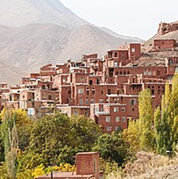 | 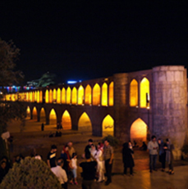 | 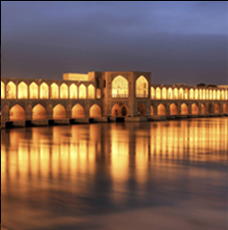
Abyaneh Village | Si-o-Se Pol Bridge | Khajoo Bridge

Day 6: Isfahan – Matinabad [2 h 5 min (166 km)]
A full Day Isfahan tour, one of the most historical cities of Iran with beautiful Islamic architecture. Due to too many places to visit, Iranian call Isfahan as "Half of the World".
- Chehel Sotoun Palace: Chehel Sotoun is a pavilion in the middle of a park at the far end of a long pool, in Isfahan, Iran, built by Shah Abbas II to be used for his entertainment and receptions.
- Naqsh-e Jahan Square: Naqsh-e Jahan Square, is a square situated at the centre of Isfahan city, Iran. Constructed between 1598 and 1629, it is now an important historical site, and one of UNESCO's World Heritage Sites. It is 160 metres wide by 560 metres long.
- Imam Mosque: The Shah Mosque, also known as Royal Mosque or Imam Mosque after the Iranian revolution, is a mosque in Isfahan, Iran, standing in south side of Naghsh-e Jahan Square. Built during the Safavid Empire, ordered by Abbas I of Persia.
- Aali Qapoo Palace: Built at the very end of the 16th century as a residence for Shah Abbas I, this six-storey palace also served as a monumental gateway to the royal palaces that lay in the parklands beyond (Aali Qapu means ‘Gate of Ali’). Named after Abbas ’hero, Imam Ali, it was built to make an impression, and at six stores and 38m tall, with its impressive elevated terrace featuring 18 slender columns, it dominates one side of Naqsh-e Jahan (Imam) Square.
- Sheikh Lotf Allah Mosque: Sheikh Lotfollah Mosque is one of the architectural masterpieces of Iranian architecture that was built during the Safavid Empire, standing on the eastern side of Naghsh-e Jahan Square, Esfahan, Iran.
In the evening drive toward Matinabad Eco Camp, check-in and rest the night in the middle of the Loot Desert.
O/N Matinabad Eco Camp

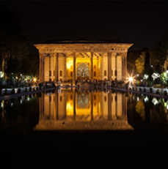 |  | 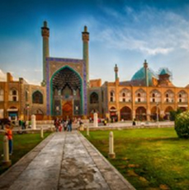 |  | 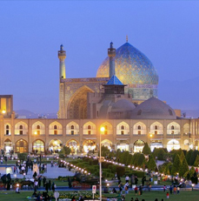
Chehel Sotoun Palace |  | Naqsh-e Jahan Square |  | Imam Mosque
 | 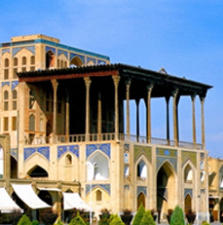 |  | 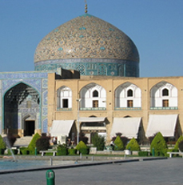
 | Aali Qapoo Palace |  | Sheikh Lotf Allah Mosque

Day 7: Matinabad – Imam Khomeini Intl. Airport [3 h 5 min (286 km)]
As the first Iranian Eco-Camp, Matinabad Eco Camp offers unforgettable adventures close to the local people and desert Nature. Harvesting in organic farm and orchards or treks on Camel or on foot, bike rides through land escapes of sand dunes and mountain gorges, desert walks, safari short trips.
In the evening Move toward IKA Airport to fly back home.

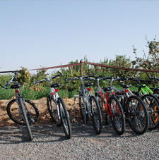 | 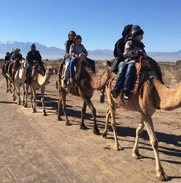 | 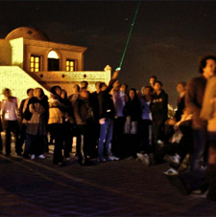
Biking | Camel Riding | Observing Stars
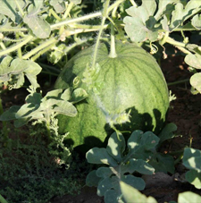 | 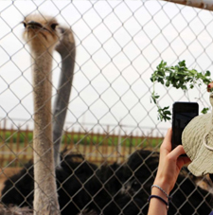 | 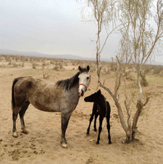
Organic Farms | Ostrich Farm | Horse Breeding Farm

Day 8: Tehran/ Kuala Lumpur (Return – 8hr00min Flight)
Arrival in Kuala Lumpur, home sweet home!

Guide Map:
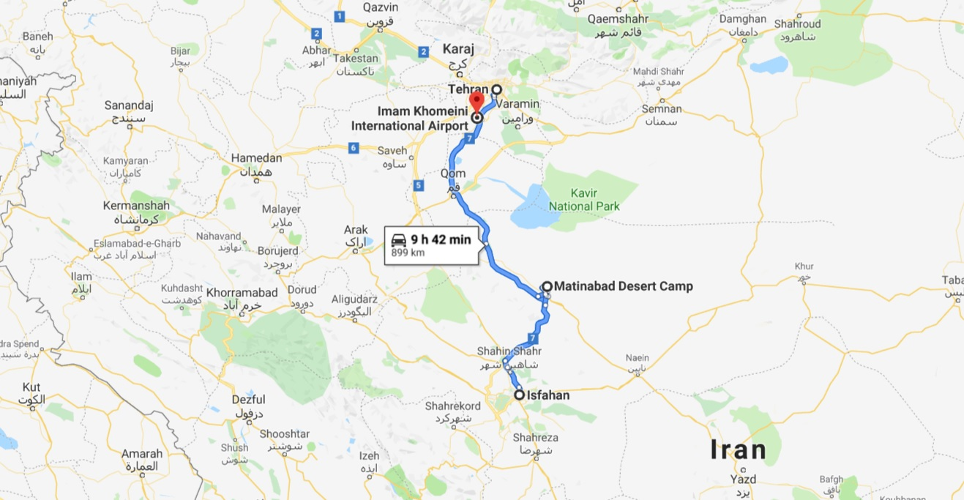

IRAN at a Glance Services
CITY | 4 Stars HOTELS | NIGHT
Tehran | Esteghlal West Tower | 2
Isfahan | Khajoo Hotel | 1
Kashan | Matinabad Eco-Camp | 1
Dubai | Hilton Garden inn Al Muraqabat Hotel | 1
TOUR INCLUSIONS | - All Flights  - All transfers V.I.P  - All entrance fees  - English Tour guide throughout the tour  - Full Board Meal + Daily refreshment  - Travel Insurance
TOUR EXCLUSIONS | - Any extra meals  - Any Extra Expenses  - All expenses from private nature such as  Phone/Fax/ Laundry/ Room Services  - Tips 30 USD Per Passenger

CHILD DISCOUNT on Ground Tour:
- Age of 03-07 years old child sharing room with two adults (CHILD EXTRA BED) 25 % DISCOUNT
- Age of 03-07 years old child sharing room with two adults (CHILD NO BED) 40 % DISCOUNT
- Age of 03-07 years old child sharing room with one adult (CHILD TWIN) NO DISCOUNT
- Age of 00-02 years old child sharing room with two adults (INFANT) 100% DISCOUNT
- Age of 7 years and above no child discount is provided (ADULT)

ACCOMODATIONS:
Parsian Esteghlal International Hotel (west wing) in Tehran
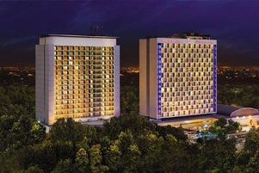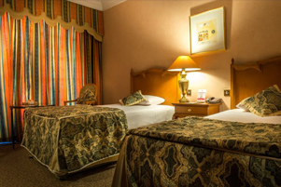
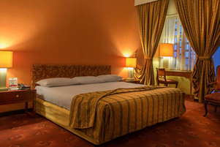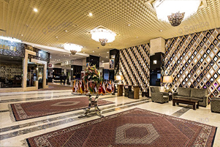
Khajoo Hotel in Isfahan
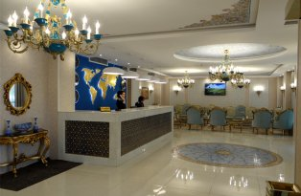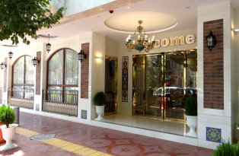
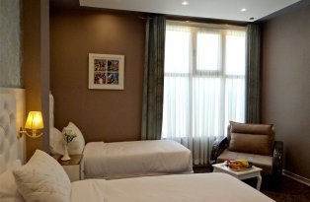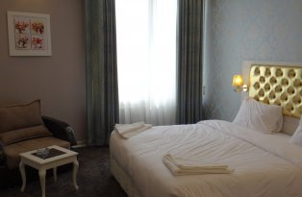

Matinabad Desert Camp
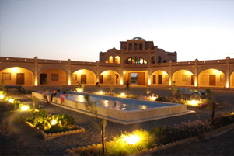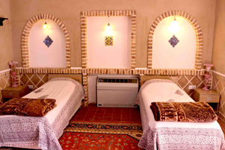
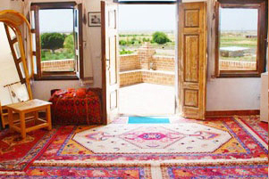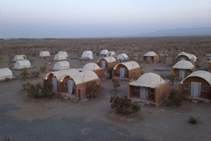

Hilton Garden inn Al Muraqabat Hotel in Dubai
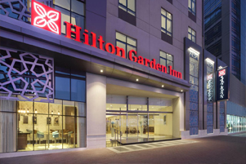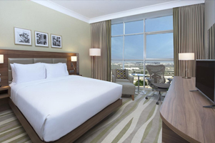
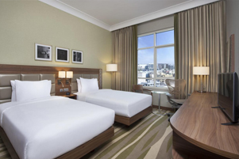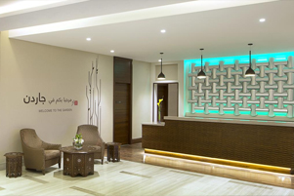
Transportation:

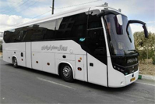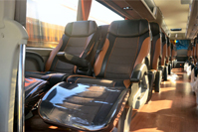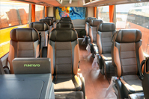
V.I.P Bus 25-31 Seats 3 Rows

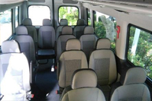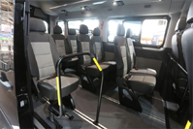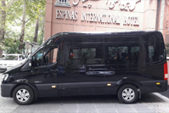
Hyundai H350 | Van 14 Seats Full Height

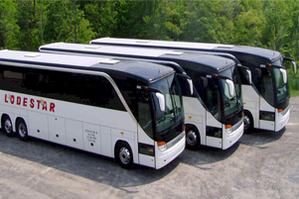

Meals (Mixture of Buffet & Traditional Restaurant):
