Balkan: Athens to Zagreb
11Days & 9nights
Cities: Athens (1N), Kalabaka (1N), Tirana (1N), Dubrovnik (1N), Mostar (1N), Sarajevo (2N), Bihac (1N), Zagreb (1N)
Flight Details:
1. From Kuala Lumpur (KUL) to Athens (ATH)
Kuala Lumpur (KUL) to Dubai (DXB)
Departure: KUL 10:20 | Arrival: DXB 13:15
Dubai (DXB) to Athens (ATH)
Departure: DXB 16:20 | Arrival: ATH 20:25
2. From Zagreb (ZAG) to Kuala Lumpur (KUL)
Zagreb (ZAG) to Dubai (DXB)
Departure: ZAG 15:25 | Arrival: DXB 23:00
Dubai (DXB) to Kuala Lumpur (KUL)
Departure: DXB 3:10(+1) | Arrival: KUL 14:25

Day 1: Kuala Lumpur - Athens

Departure at 10:20am from Kuala Lumpur. Arrival to Athens at 8:25pm at night and meet our guide, then transfer to hotel and Check-In.
O/N Athens

Day 2: Athens - Kalabaka (6h - 360km)

Breakfast in hotel and check out. Start city tour with local guide visiting
- Acropolis
- Parthenon
- Olympic Stadium
- Zeus Temple
- Presidential Mansion
- Tomb of Unknown Soldier
Then transfer to Kalabaka and having Kalabaka Monestry tour by bus. Transfer to hotel and check-in.
O/N Kalabaka
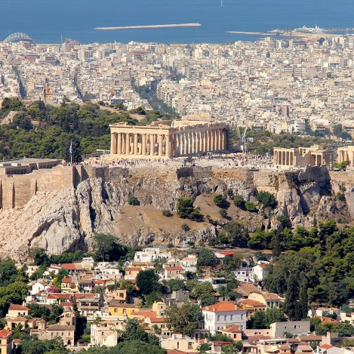 | 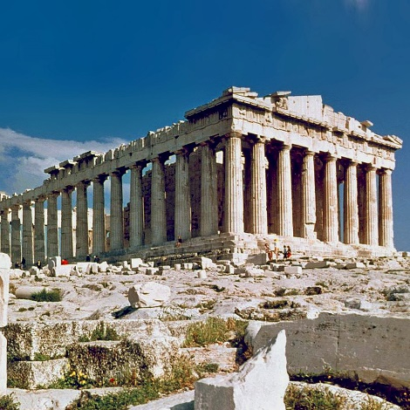 | 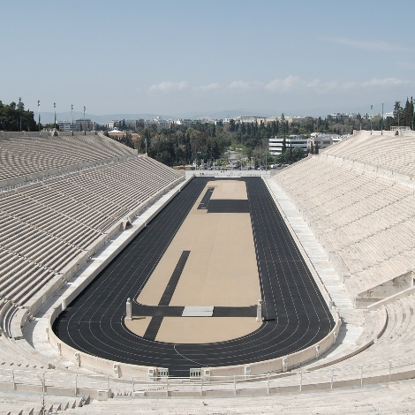
Acropolis | Parthenon | Olympic Stadium
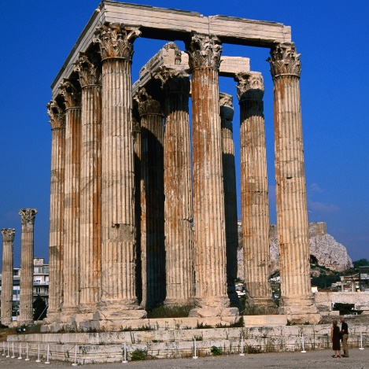 | 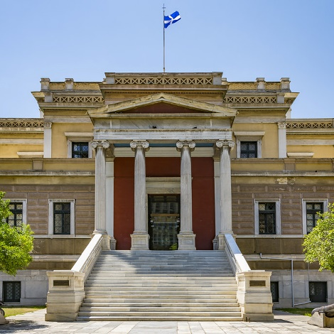 | 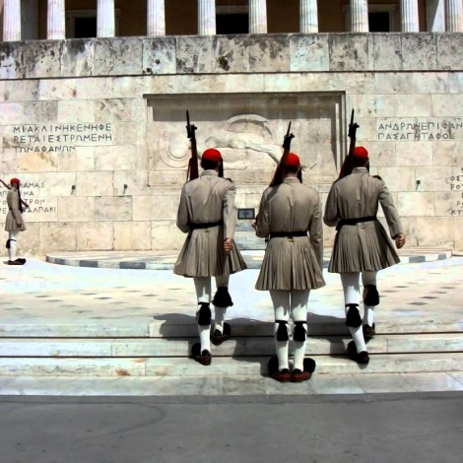
Zeus Temple | Presidential Mansion | Tomb of Unknown Soldier

Day 3: Kalbaka - Ohrid - Tirana (7h - 450km)
Kapali Carsi
Kapali Carsi

After a nice breakfast in Kalabaka, check-out to head to Tirana. On the way have a stop in Orchid for lunch and Solat in Bitola, then have quick tour of Orchid. Visitng:
- Cinar Square
- Orchid Lake
- Kuloglu Mesjid
Continue toward Tirana, the capital of Albania, is known for its colorful Ottoman-, Fascist- and Soviet-era architecture.
O/N Tirana
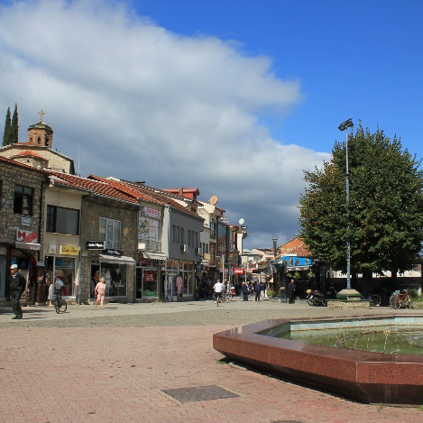 | 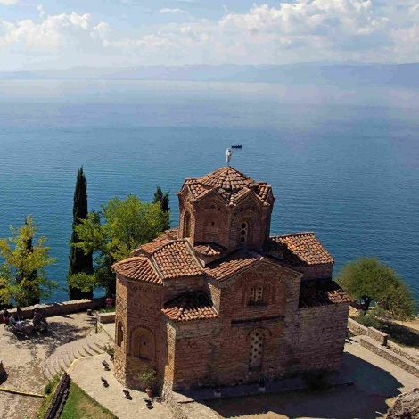 | 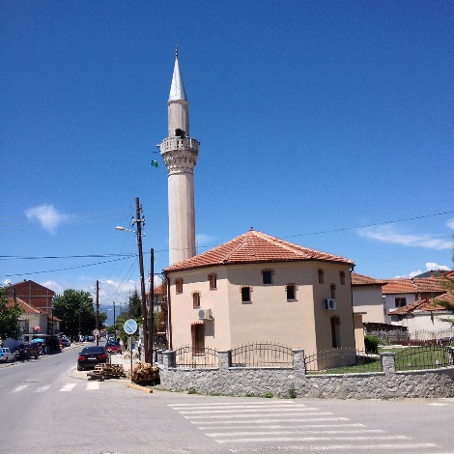
Cinar Square | Orchid Lake | Kuloglu Mesjid
Kapali Carsi
Day 4: Tirana - Kotor - Dubrovnik (6h 30min – 300km)

Breakfast in Tirana and check out for Tirana city tour, visiting:
- Parliament Building
- Ethem Bey Mosque
- Mother Teresa Boulevard
- Skanderbeg Square
- National Theatre of Opera and Ballet

Stop at Bar Islamic Centre for lunch and Solat. Continue to Kotor and visit old town:
- Pillar of Shame
- Arms Square
- Tourist School Square

Transfer to Dubrovnik and check-in to the hotel.
O/N Dubrovnik

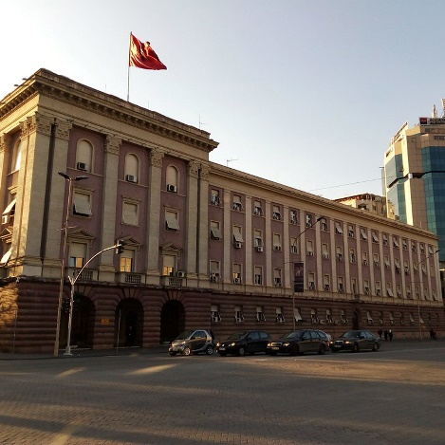 | 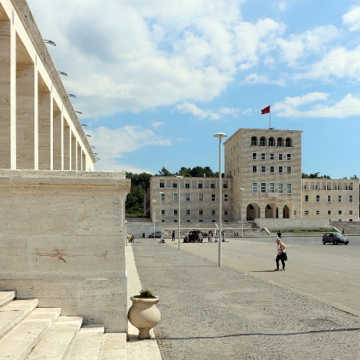 |  | 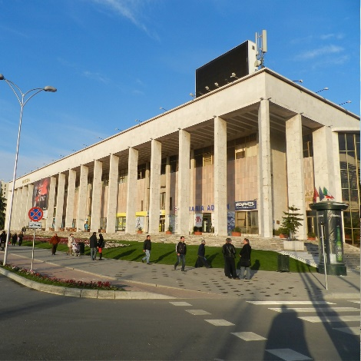
Parliament Building | Mother Teresa Boulevard |  | National Theatre of Opera
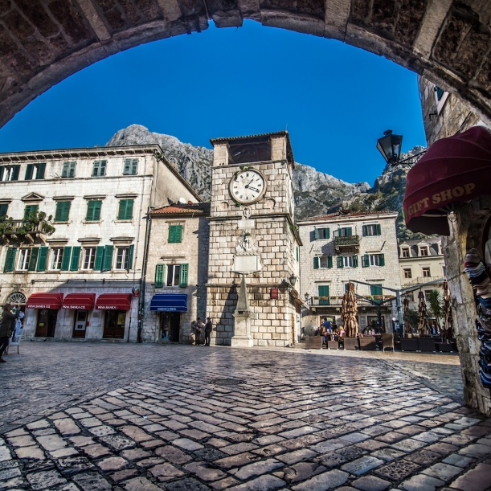 |  | 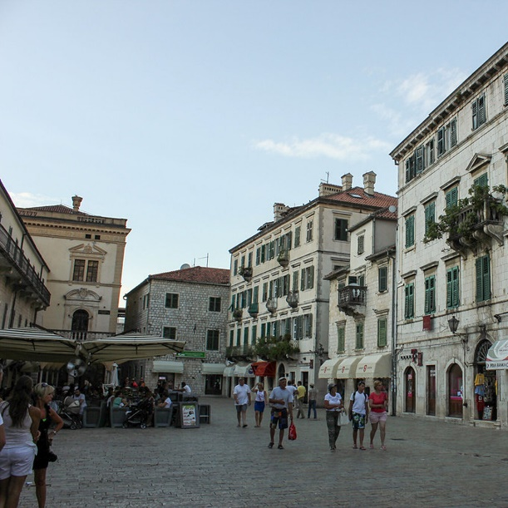
Pillar of Shame |  | Arms Square

Day 5: Dubrovnik – Mostar (3h - 150km)
After the breakfast you will be guided by our tour guide for Dubrovnik city tour:
- Old Town
- Rector's Palace
- Stradun Main Street
- Old Port
- Homeland War Museum
- Time Tower

Head toward Mostar, on the way stop at Pocitelj old ottoman town and visit Ali Pasha Mosque and Citadel. Upon arrival to Mostar you will visit:
- Old Bridge
- Souvenir’s Street
- Karađoz Bey Mosque
- Koski Mehmed Pasha Mosque
- Ottoman Bath

Transfer to hotel and chek-in.
O/N Mostar

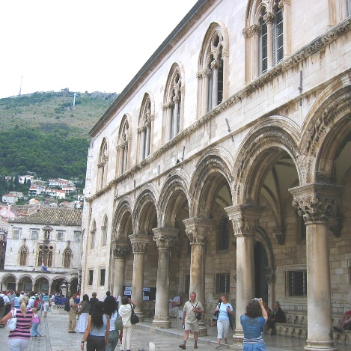 | 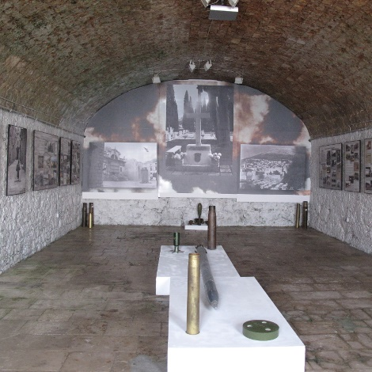 | 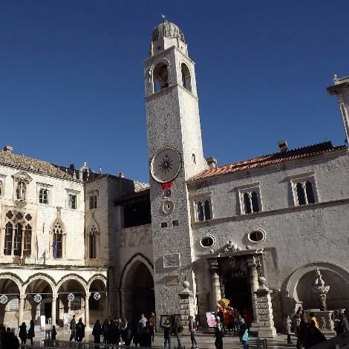
Rector's Palace | Homeland War Museum | Time Tower
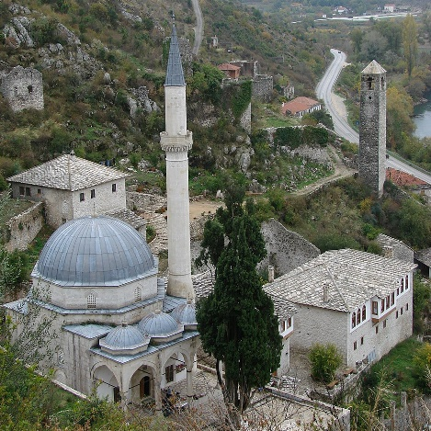 | 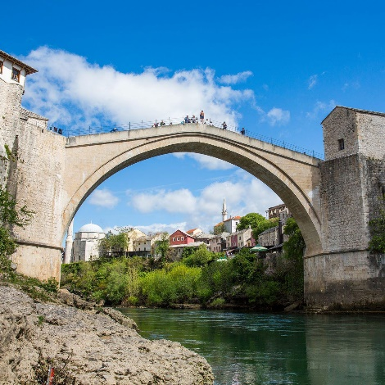 | 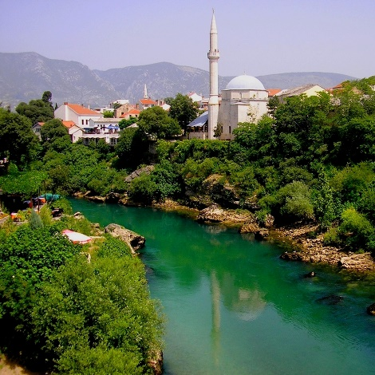
Old Bridge | Karađoz Bey Mosque | Koski Mehmed Pasha Mosque

Day 6: Mostar – Blagaj – Sarajevo (2h 30min - 125 km)
After breakfast transfer to Blagaj and visit:
- Dervish House
- Buna River Spring

Continue to Sarajevo. On the way stop in Jablanica for lunch and Solat. Then you will have Old Town city tour by visitng:
- Gazi Husrev-beg Mosque
- Inat Kuca
- Vijećnica
- Sebilj
- Gazi Husrev-beg's Madrasa
- Sacred Heart Cathedral

Transfer to the hotel and check-in
O/N Sarajevo

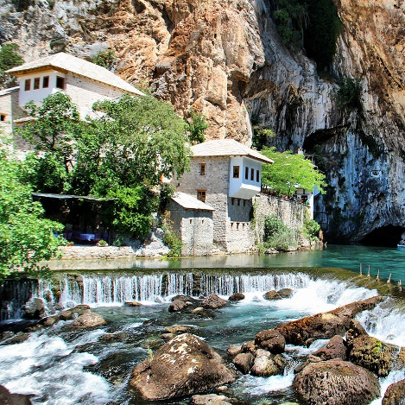 | 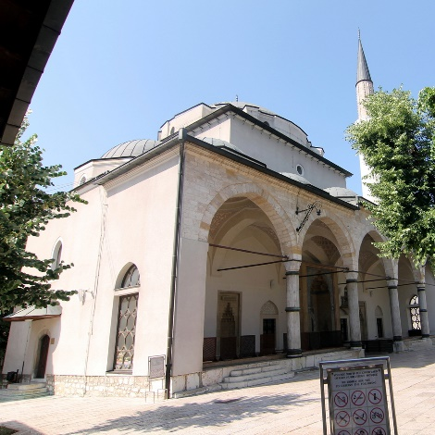 | 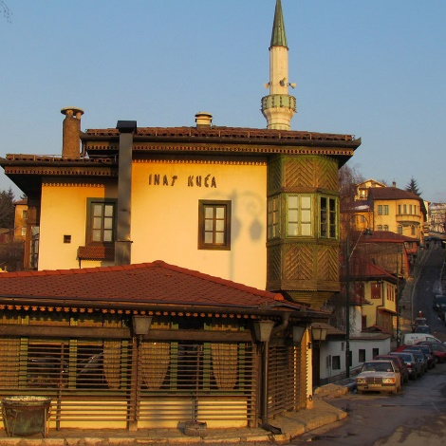
Dervish House | Gazi Husrev-beg Mosque | Inat Kuca
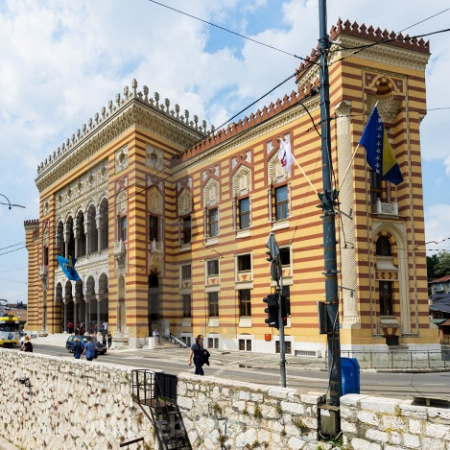 | 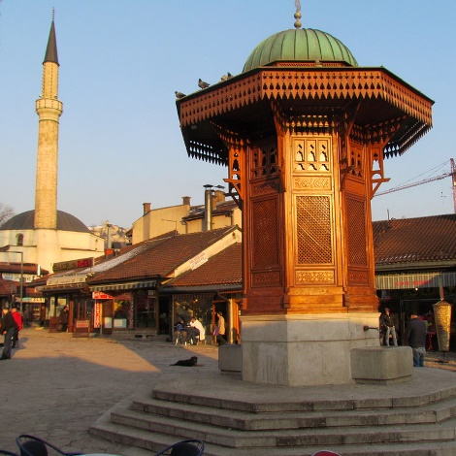 | 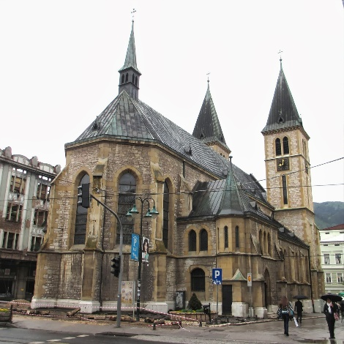
Vijećnica | Sebilj | Sacred Heart Cathedral

Day 7: Sarajevo

After your breakfast get ready for a full day Sarajevo city tour, visiting:
- Sarajevo Tunnel
- Vrelo Bosne Park (use horse ride on the couch)
- Sarajevo Olympic Mountains (Solat in a nearby mosque)
- Latin Bridge & Brusa Bezistan
- OPTIONAL Sarajevo cable car ride 13€/pax

Dinner and transfer to the hotel.
O/N Sarajevo

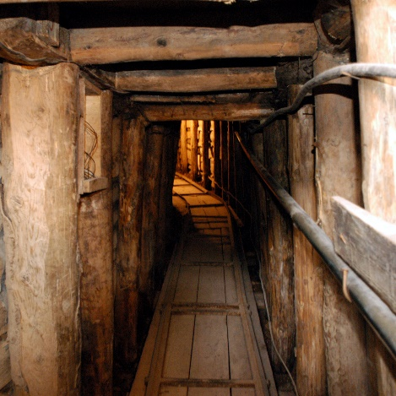 | 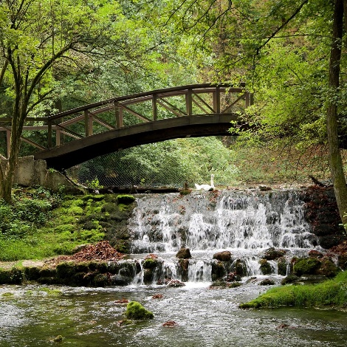 |  | 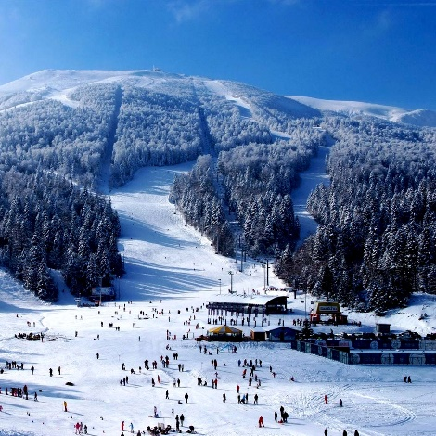
Sarajevo Tunnel | Vrelo Bosne Park |  | Sarajevo Olympic Mountains
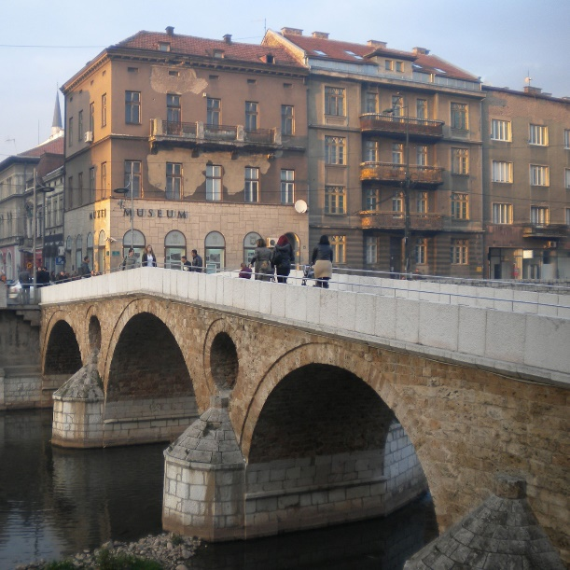 |  | 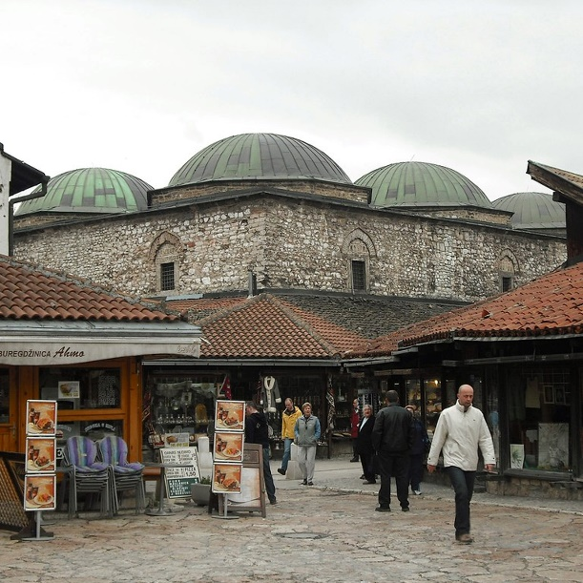
Latin Bridge |  | Brusa Bezistan

Day 8: Sarajevo - Jajce – Bihac (5 h 30 min - 300 km)
After having your breakfast get ready for a ride to Travnik and photo stop at:
- Blue River
- Elči Ibrahim Pascha Medresa
- Sulejmanija Mosque
Continue your journey to Jajce and stop at Jajce Water Fall. After lunch, drive toward Bihac and check-in to the hotel.
O/N Bihac

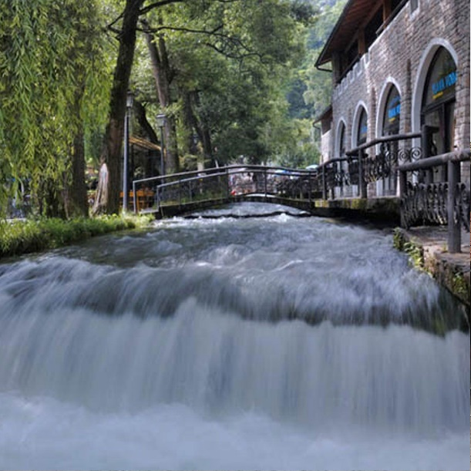 | 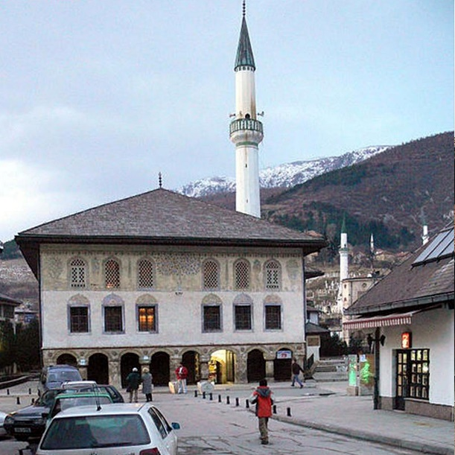
Blue River | Sulejmanija Mosque

Day 9: Bihac - Zagerb (2h 30 min-150 km)

After having your breakfast in Bihac, you shall get ready for a ride to Zagreb. On the way 3 hours tour of:
- Plitvice Lake

Transfer to Zagreb and check-in to the hotel. Then visiting:
- Zagreb City
- Dinner and Solat in Islamic Centre of Zagreb
O/N Zagreb

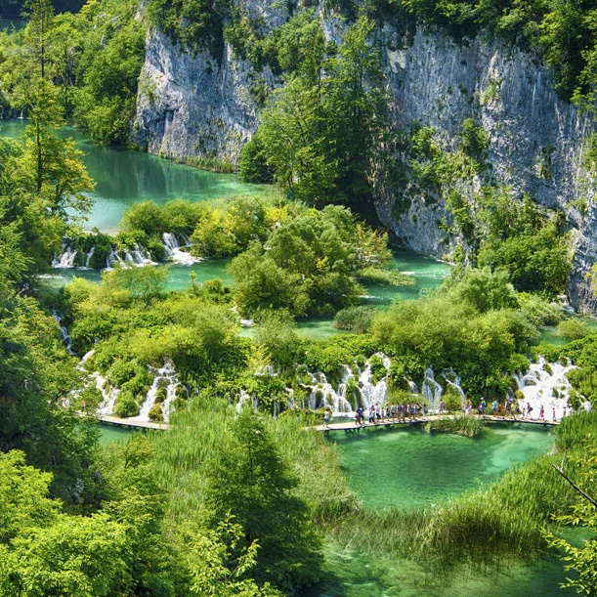 | 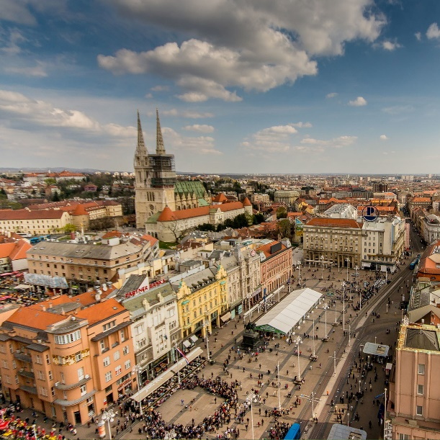
Plitvice Lake | Zagreb City

Day 10: Zagreb - Departure (3h-250 km)
Breakfast at the hotel and check-out for Zagreb City tour, visiting:
- Dolac Market
- Kaptol
- Stone Gate
- St. Mark's Church
- Lotrščak Tower
- Ban Jelacic Square
Have your lunch and Solat. Spent a free time in Maksimir Park and transfer to airport for Departure.
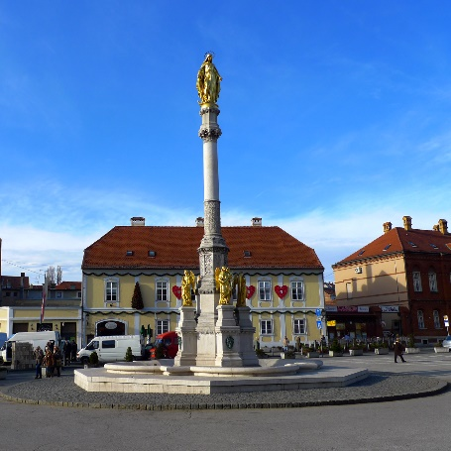 | 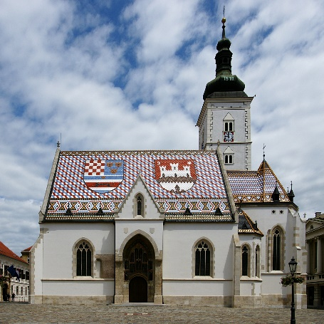 | 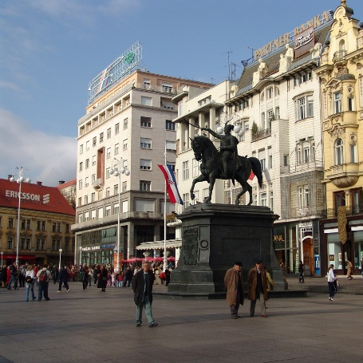
Kaptol | St. Mark's Church | Ban Jelacic Square

Day 11: Kuala Lumpur (Arrival)
Landing at 2:25 pm in the Kuala Lumpur International Airport with sweet memories.
TOUR INSCLUSIONS | TOUR EXCLUSIONS
- International Flight by Emirates  - Transport with luxury touristic  BUS (air condition, TV)  - Accommodation in 4-star hotels (9 nights)  - Halal meals 9 dinners  tour guiding  - Arrangement and tour leader  - Entrance Fees as per Itinerary | - Private costs during travelling  - Tips 50 USD Per Passenger
INCLUDED ENTRANCES
- Acropolis, Blagaj tekija, War Tunel, Spring of river Bosna, Plitvice lake national park

CHILD DISCOUNT
- Age of 3-7 years old child sharing room with two adults (CHILD EXTRA BED) 25 % DISCOUNT
- Age of 3-7 years old child sharing room with two adults (CHILD NO BED) 40 % DISCOUNT
- Age of 3-7 years old child sharing room with one adult (CHILD TWIN) NO DISCOUNT
- Age of 0-2 years old child sharing room with two adults (INFANT) 100% DISCOUNT
- Age of 7 years and above no child discount is provided (ADULT)

Transportation:
